AP Biology Name ___________________________
Chapter 54 Guided Reading

- What is an ecosystem and why would we study energy flow in relation to the ecosystem?

- Label the diagram below.
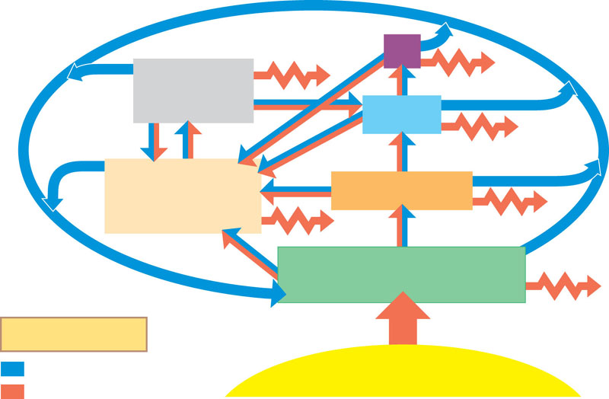
- Why are detrivores essential to an ecosystem?

- Define the following terms:
  - Gross primary production

  - Net primary production

- How do light limitations and nutrient limitations impact primary production?

- What is eutrophication and is it considered a “positive” for a lake environment?

- What impacts evapotranspiration?

- What is secondary production?

- Why is the energy transfer between trophic levels limited?

- What is the difference between production efficiency and tropic efficiency?

- What is the green world hypothesis?
- Complete the diagram below of the general model of nutrient cycling.
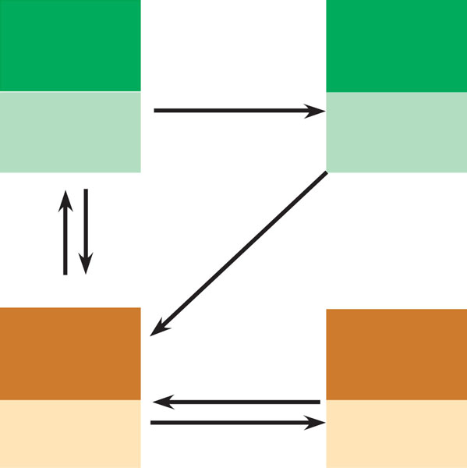
- Briefly detail the water cycle. You can write this response or draw the cycle.

- Briefly detail the carbon cycle. You can write this response or draw the cycle.

- Briefly detail the nitrogen cycle. You can write this response or draw the cycle.
- What is the difference between nitrification, denitrification, ammonification and nitrogen fixation?

- Briefly detail the phosphorus cycle – you can write your response or draw a picture.

- Imagine you are at the dinner table and are asked to explain what acid rain is and why it is a problem. Write your response here.

- What is biological magnification and how does it relate to the health warnings given to pregnant women about the consumption of certain fish?

